**Scalable surveillance of e-cigarette products on Instagram and TikTok using computer vision**

Julia Vassey1 & Chris J. Kennedy2,3 , Ho-Chun Herbert Chang4,5, Ashley S. Smith1, Jennifer B. Unger1

1. Department of Population and Public Health Sciences, University of Southern California, Los Angeles, CA

2. Center for Precision Psychiatry, Massachusetts General Hospital, Boston, MA

3. Department of Psychiatry, Harvard Medical School, Boston, MA

4. Department of Quantitative Social Science, Dartmouth College, Hanover, NH

5. Information Sciences Institute, Viterbi School of Engineering, University of Southern California, Los Angeles, CA

E-cigarette/Vaping Image Annotation Guidelines

# Introduction

The goal of this project is to review social media posts, particularly those from Instagram and TikTok, for promotion of e-cigarette (vaping) products and create an accurately labeled dataset that can be used to train computer algorithms. This document describes how to mark images posted on social media with the specific location of different types of e-cigarette/vaping objects. We are using V7 Labs software to manage this annotation process.

# A. Image annotation

When reviewing images posted to Instagram, the task is to identify specific types of objects related to e-cigarettes (vaping) and place accurate bounding boxes around those objects. It is important to not miss any objects that we want to label, and that the bounding boxes be placed tightly around the object. By “tight” we mean that the bounding box should touch the edges of the object and the object should not extend outside of the bounding box. If we can collect a large number of accurately labeled images, we will be able to create a computer algorithm that can learn to do the same thing automatically to track e-cigarette promotion trends.

Table 1 below shows the 8 types of objects that we want to annotate in social media images.

**Table 1. Objects to identify in images and annotate with a bounding box.**

|  |  |  |
| --- | --- | --- |
| **Object** | **Example** | **Description** |
| 1. Mod device |  | Big, bulky, often box-looking, rebuildable, modifiable e-cigarette (vape) devices for advanced vape users. Includes mod kits, boxes, atomizers, and accessories. |
| 2. Pod device |  | The newest generation of e-cigarette (vape) products, often for e-cigarette use (vaping) beginners. They are smaller and slicker than mods. Includes disposable, refillable, and rechargeable pod devices. |
| 3. E-juice bottle |  | Bottles of nicotine or non-nicotine e-juices. |
| 4. Box |  | Packaging of e-juice, mod or pod devices. |
| 5. Smoke cloud |  | Exhaled smoke. |
| 6. Nicotine warning label |  | Warning label in an image/video or placed on an e-cigarette product featured in an image/video that contains the word “nicotine”. |
| 7. E-juice flavor name |  | Presence of an e-juice flavor name (e.g., Lychee Ice) on an e-cigarette product. |
| 8. E-cigarette brand name |  | Presence of an e-cigarette brand name (e.g., The Dollar E-Juice Club) on an e-cigarette product. |

# B. Detailed description of object types

**Mod devices** are big, bulky, often box-looking, rebuildable, modifiable vaping devices for advanced e-cigarette (vape) users. They are popular among those vapers who do vape tricks or clouds.

We assign a ***mod*** label to:

1. Mod kits

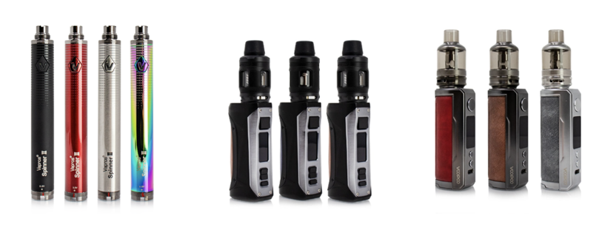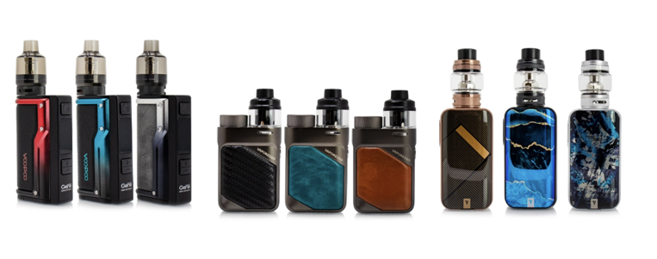

1. Mod boxes (body of a mod) 3) Mod atomizer (top part of a mod)

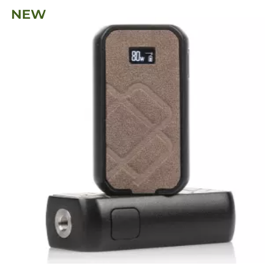 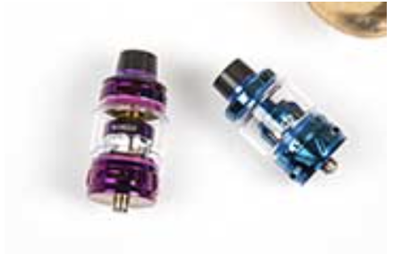

4) Mod accessories (wick, coil, mesh, wire)

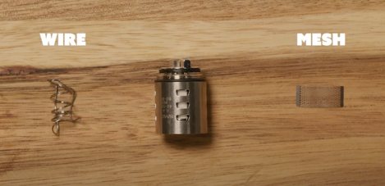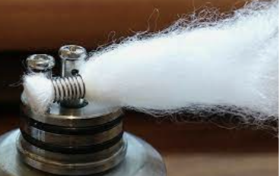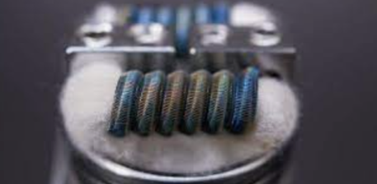

wire and mesh wick (white material) coil and wick

**Pod devices**, also called e-cigarette (vape) pods, pod vapes and pod mods are the newest generation of e-cigarette (vaping) products, often for e-cigarette use (vaping) beginners. They are smaller and slicker than mods.

We assign a ***pod*** label to:

1. Disposable pod devices:

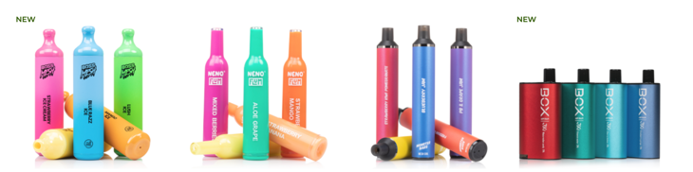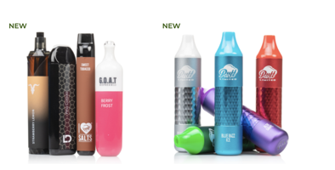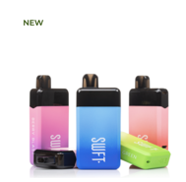

1. Small rechargeable (cartridge-based or juul) and refillable devices:

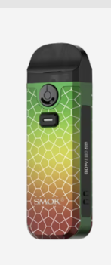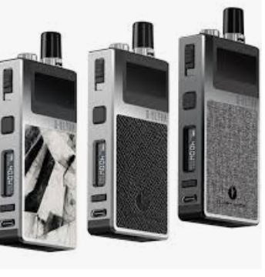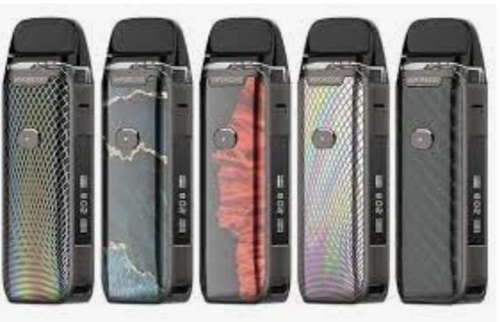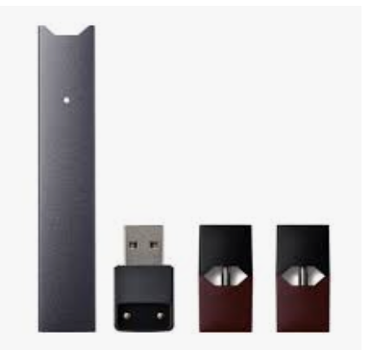

c) Pod mod systems. These devices somewhat resemble traditional mods, but they are smaller and slicker than mods.

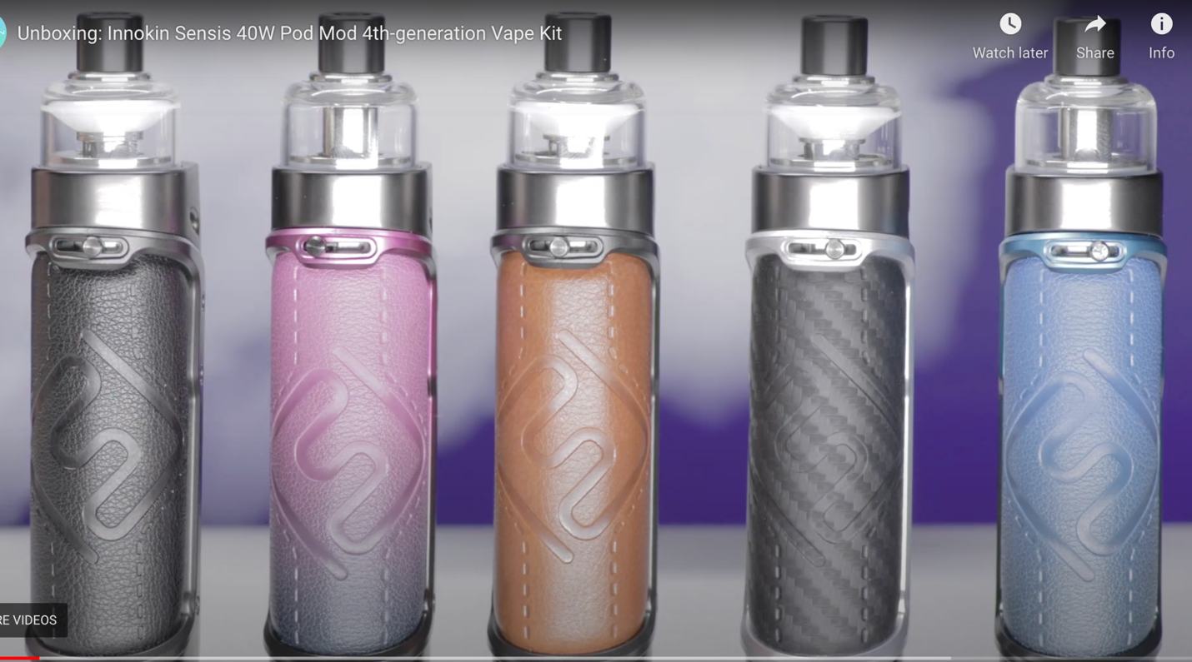

Examples below illustrate a very nuanced difference between some brands of mods and pod mods. Very tricky!

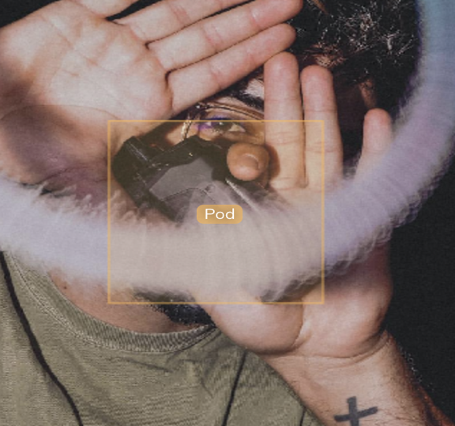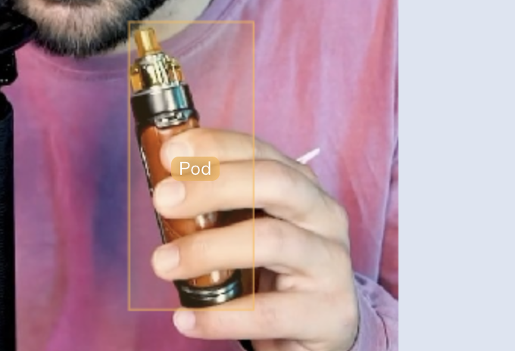

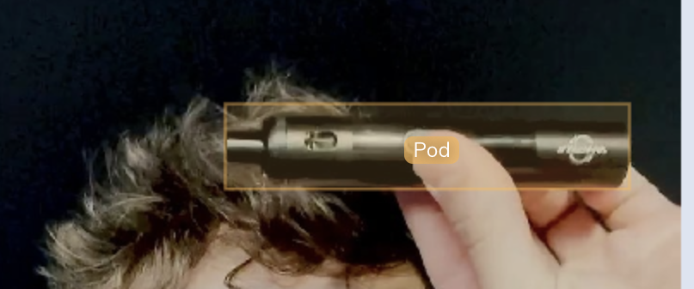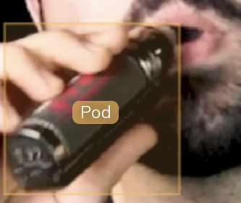

The 4 images above are ***pod mod***devices *(which we label as* ***pod****)*, because compared to traditional mod devices, they are slightly smaller, have somewhat rounded edges around the boxes and a small top (atomizer). Sometimes a brand name is visible on a device. When in doubt, try to zoom in, read the brand name and google it to see the description of a device. If it is described as *pod mod*, please, label it as *pod.*

Two images below are ***mods:*** the first one has a large rectangular box and both have quite pronounced atomizers.

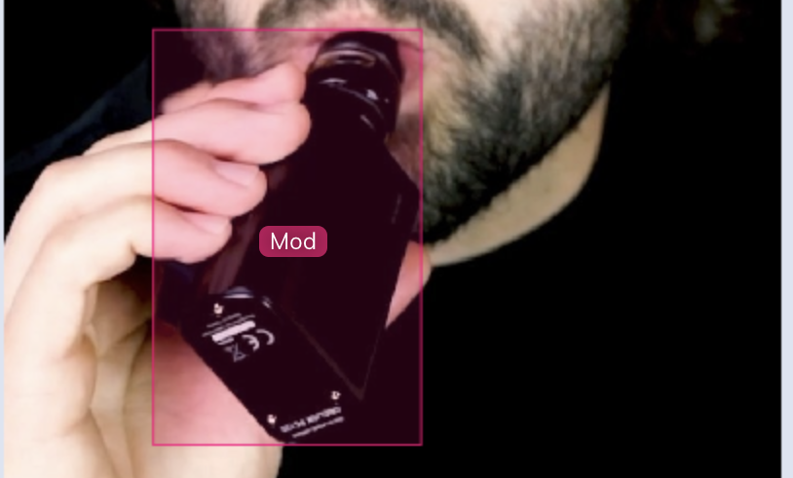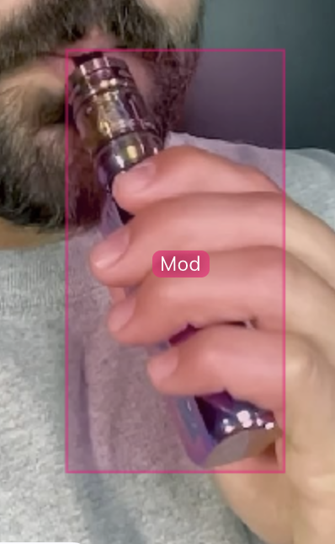

**E-juices**, also called e-liquids, are liquids used inside e-cigarettes. E-liquids may contain nicotine (regular or synthetic).

We assign an ***e-juice*** label to:

Bottles of e-juices or nicotine salts:

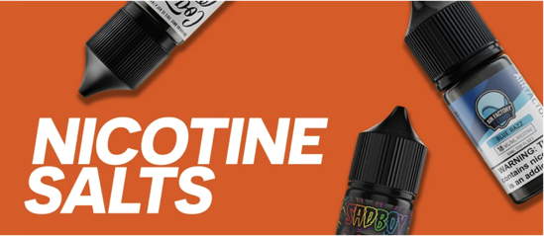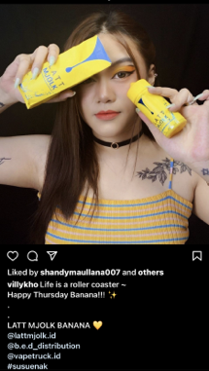

Bottle of e-juices e-juice bottle and a packaging box

### **Box** is referred to e-juice, pod or mod packaging.

E-juice packaging:

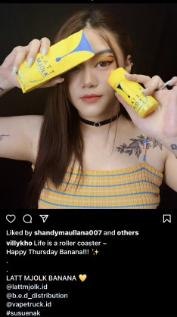

e-juice bottle and a packaging box

**A warning label** is a label required by the Federal Food and Drug Administration (FDA) to be placed on any tobacco product packaging, including tobacco marketing materials, such as promotional e-cigarette images on social media.

We assign a ***nicotine warning label*** to images containing corresponding labels anywhere on an image or video:

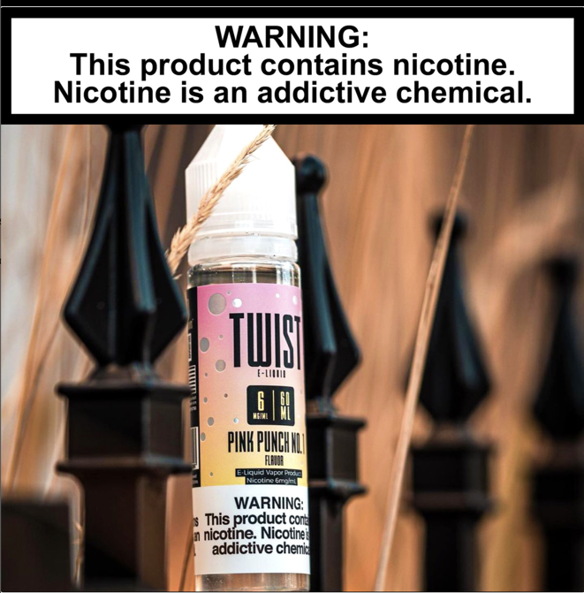

In this example, draw a bounding box over the warning label on the e-juice container and over the label at the top of the image.

For e-cigarette brand names or flavor names bounding boxes should be applied to names displayed on the devices (e.g., Lychee Ice). Brand names sometimes can be represented as logos (right image) and should be labeled with the bounding box as well.

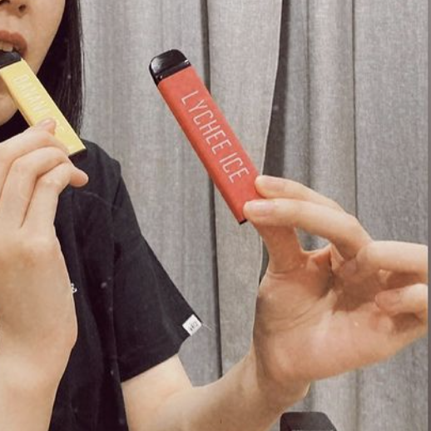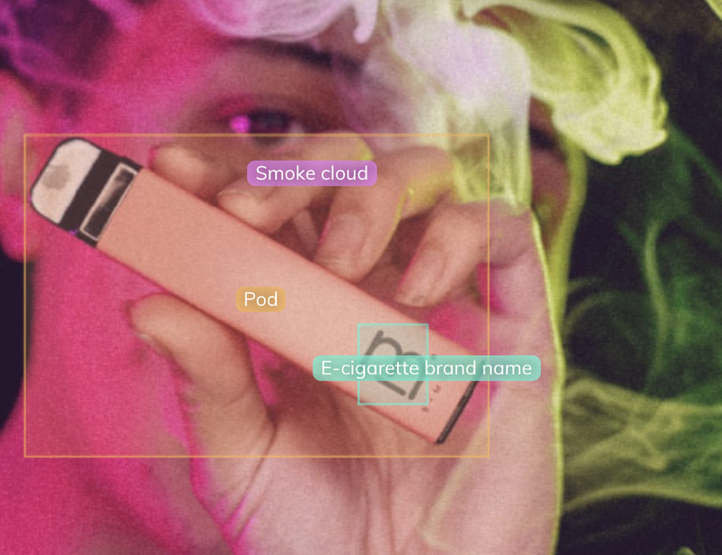

# C. Examples of labeling using bounding boxes

1. When using V7 software, ONLY a bounding box should be used for all objects. (Polygons that allow to draw a contour over a labeled object vs a rectangular box will not be used for annotating at the moment. Polygons are more complex to analyze, which is beyond the scope of this project).
2. A bounding box needs to be drawn tightly around each object we categorized above (e.g, face, cloud, pod or mod device, e-juice). One limitation: the software does not allow you to rotate boxes!

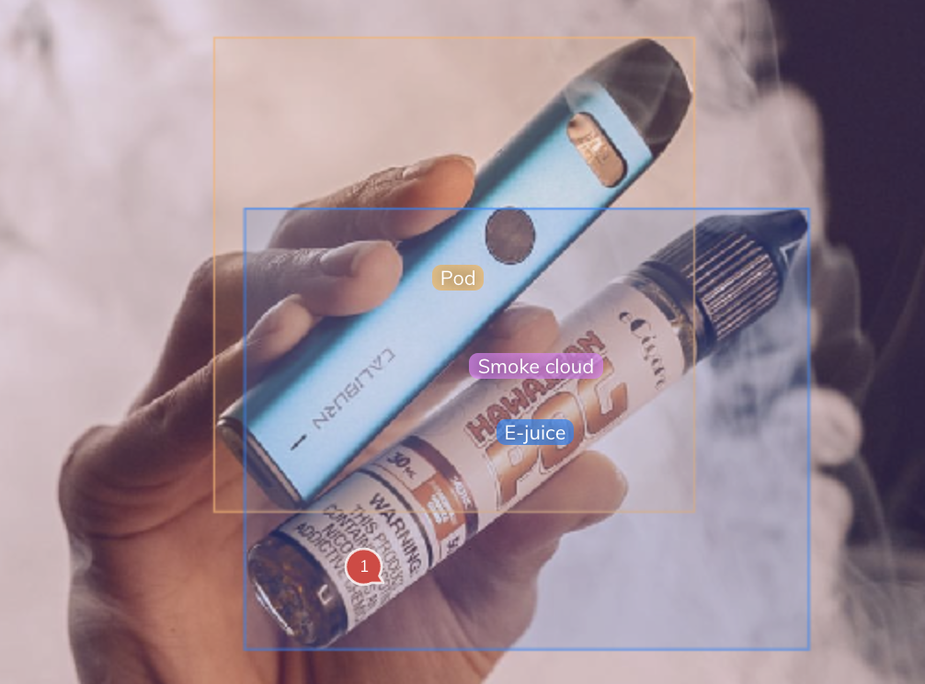

## Additional clarifications

1. All objects of the defined categories should be labeled, unless an annotator is unsure of what the object is.
   1. Multiple objects of the same type need separate bounding boxes, even if they are adjacent to each other.

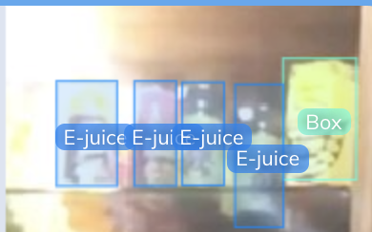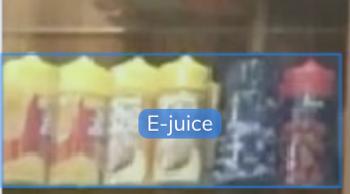

**correct incorrect**

* 1. Particularly in the case of smoke clouds, if the clouds are not connected use separate bounding boxes.

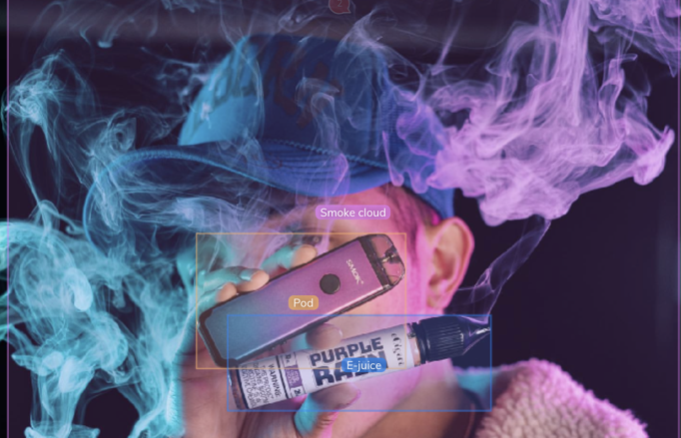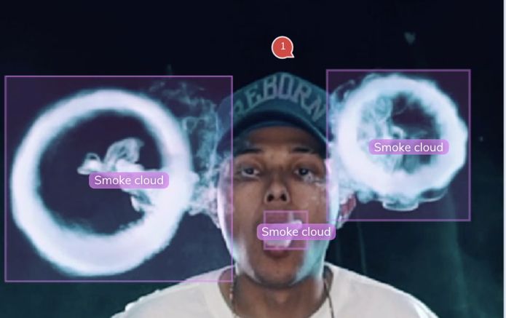

**connected cloud = one cloud label disconnected clouds = three cloud labels**

1. Bounding boxes should be drawn **tightly** around an object.
   1. Use the scroll wheel on your mouse or two-finger scrolling on your trackpad to zoom in to the object and achieve a more accurate bounding box.
   2. If the object visibly extends outside of the bounding box, the box is overly tight and needs to be expanded.
   3. If there is a visible gap between the edge of the object and the edge of the bounding box, the box is too large and should be tightened.

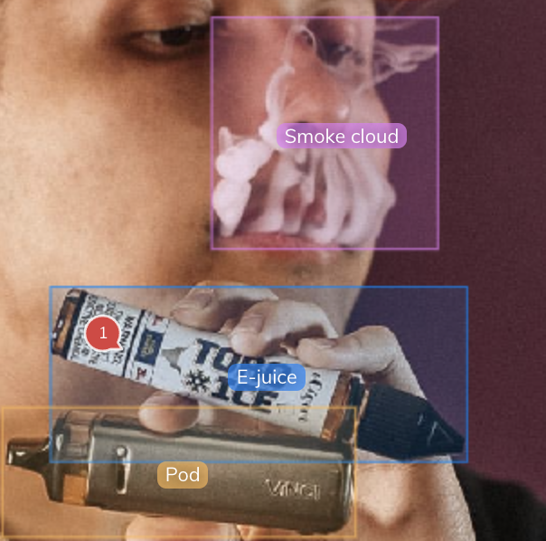

* 1. If the end of an object is hidden by something else (e.g. a finger), don’t extrapolate the bounding box beyond what is visible of the object. I.e. don’t include the finger within the bounding box, unless the object extends past the finger.

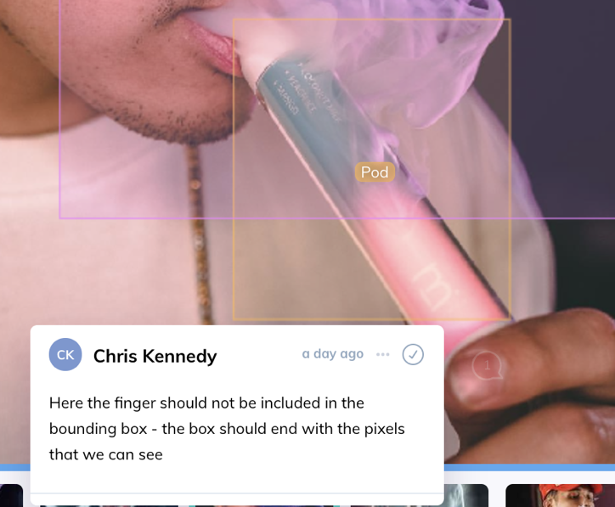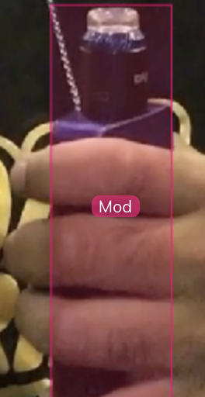

**box is not extrapolated object is visible despite partial occlusion**

1. If an object is blurred or is located in the background of an image, it still needs to be labeled. However, if an annotator is in doubt about what label to assign and the category seems ambiguous because of the low image resolution (blurriness), the image should not be labeled. An exclude tag created in V7 should be applied.
2. If not all the words are distinguishable on warning labels, but an annotator can guess what the words are based on the context, the image needs to be labeled.

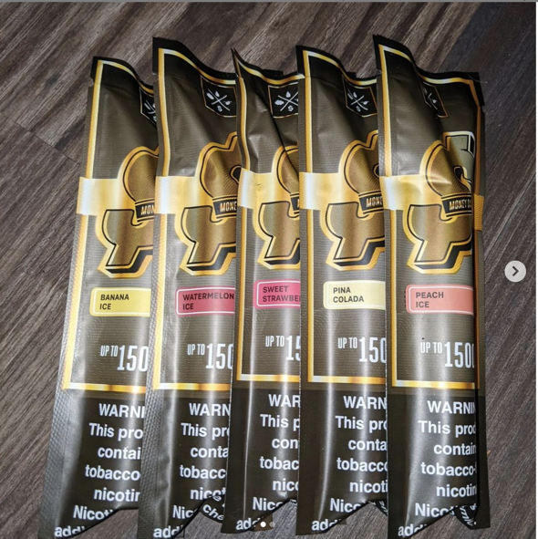

**D. Non-e-cigarette objects**

To decrease the rate of false positives, we are also including images featuring a variety of objects unrelated to e-cigarettes. Do not label objects in these images, but only tag them as “non-vaping” in the V7 labeling software.

The following hashtags were used to collect images unrelated to e-cigarettes.

**1. #bookcollection**

**2. #handspunyarn**

**3. #sanrioplushies**

**4. #bulletjournaling**

**5. #japanesefruit**

**6. #foodphotography**

**7. #antiquecollection**

**8. #benchmade**

**9. #bbq**

**10. #dogs**

**11. #daiso**

**12. #interiordesigninspiration**

**13. #dessertphotography**

**14. #notestagram**

**15. #homecafe**

**16. #theshoegame**

**17. #bentleycontinental**

**18. #aestheticdesk**

**19. #pastarecipe**

**20. #incenseholder**

**21. #makeupproducts**